POS High-Level Architecture



Design Document

Copyright © 2012 Retalix Ltd.
All rights reserved.
Israel  10 Zarhin St.  P.O. Box 2282  Ra’anana 43000, Israel  Tel: +972 9 7766677  Fax: +972 9 7400471  Website: http://www.retalix.com | USA  6100 Tennyson Parkway  Suite 150, Plano, TX 75024 USA.  469-241-8400  Website: http://www.retalix.com
Retalix technical documentation and the product(s) described herein are protected by one or more U.S. copyrights, patents, foreign patents, or pending applications. No part of this publication may be reproduced or transmitted into any human or computer language in any form or by any means, stored in a retrieval system, transmitted, redistributed, translated or disclosed to third parties, or de-compiled in any way including, but not limited to, photocopy, photograph, electronic, mechanical, magnetic or manual without the expressed written permission of Retalix Ltd., or its licensors, if any. All copies, so authorized, shall contain a full copy of this copyright notice.
Retalix products are licensed products. The product licenses convey the right to use only those specific products, components, modules, features and/or functions specified in the license agreement or contract. This publication may mention or reference products, components, modules, features and/or functions that are not part of a particular license agreement. The customer is not entitled to the receipt of, or use of, any other products, components, modules, features and/or functions that may be referenced in any documentation provided to customer unless additional license fees are paid and an appropriate license agreement is duly executed. Retalix’s obligations with respect to its products and services are governed solely by the agreements under which they are provided.
U.S. Government Users Restricted Rights: If the Customer is a United States Government entity, the Retalix products described herein are “commercial computer software” as defined by current Federal Acquisition Regulation (“FAR”), Department of Defense Federal Acquisition Regulation Supplement (“DFAR”), or other applicable Agency regulation provisions. If the Retalix products described herein are other than “commercial computer software,” then the United States Government Customer shall receive no greater than Restricted Rights, as defined in the currently applicable version of the FAR, DFAR, or other applicable Agency regulation. In the event that alternative regulatory rights allocation provisions are available to the parties, the provision which provides the Customer with the narrowest rights allocation permitted by law and regulation shall apply. For Civilian Agencies: Restricted Rights. Use, reproduction or disclosure is subject to restrictions set forth in subparagraph (a) through (d) of the Commercial Computer Software Restricted Rights clause at 52.227-19, as applicable, and the limitations set forth in standard Retalix license agreements for software and technical documentation.
This publication is furnished for informational use only and should not be construed as a commitment by Retalix. The information could include technical inaccuracies or typographical errors. Every effort has been made to make this publication as complete and accurate as possible, but it is provided “as is” without warranty of any kind either expressed or implied, including, but not limited to, the implied warranties of merchantability, fitness for a particular purpose, or non-infringement. Retalix may make improvements and/or changes in the program(s), product(s), and/or applications described in this publication at any time without notice. Due to continuous development of Retalix Ltd. products, information published in this document may become obsolete.
Third-party products, services, or company names referenced in this document may be trademarked or copyrighted by their respective owners, and are for identification purposes only.
Copyrights, trademarks and license agreements shall be governed and construed in accordance with the laws of the State of Texas and the Federal Arbitration Act, and shall benefit Retalix, its successors, and assigns.

Table of Contents
1 Introduction 1
1.1 Purpose 1
1.2 Functional reference 1
1.3 Main environment 2
1.4 Peripherals 3
2 POS Architectural Overview 4
2.1 Component view 4
2.1.1 Utils 7
2.2 Main flow 8
2.2.1 Sale Transaction 8
3 External Components and Interfaces 10
Interfaces 11
3-Party 11
4 Repository 12
4.1 Database 12
4.2 Tra file 12
4.3 Trs file 12
4.4 Registry 13
4.5 Ini file 13

History
Date | Change | Document Version | Changed By | Approved By
8/15/2012 | New document | 1.0 | Moral Carmi

Introduction

Purpose
- The POS goal is to manage all the transactions that happen in the store.
- The POS include global transaction (TTransaction) that contains Items.
- The transaction always exists in the application and the status/ fields are changed according to the state of the POS.
- Every action that happen in the POS call to event in the code that change something in the transaction.
- To be able to work with the POS need to have
  - Data base that come from the BOS and include all the information about the employee, items, payment, access etc.
  - Registry that includes the entire configuration for the customer: which function the employee sees, what happen in every event, how the receipt will look, the translation to all the system etc.

Functional reference
- Items may be sold individually or in combinations.
- Multiple payment methods such as, credit cards, coupons.
- Foreign currency and Euro.
- Support different kind of selling: Sale, Refund, OTH (on the house), SignIn, SignOut, OpenBank, CloseBank, Void, Waste, Drop etc.
- Promotions.
- On-line cash drawer media control.
- Connect to devices: Printer, Line display, Scanner, Scale, MSR and Pinpad.
- Support Fiscal printer.
- Operator control.
- Pos electronic Journal.
- Suspend and resume transactions.
- Simple and efficient use through touch screen interface.
- Graphic interface.
- Flexible and customizable sale screen.
- Enable to connect to fuel system and add fuel item to the transaction.
- Add modifier item that contain ingredients.
- Support multi language. See more in HOWTO translate.docx

Add document link to this section.

Main environment
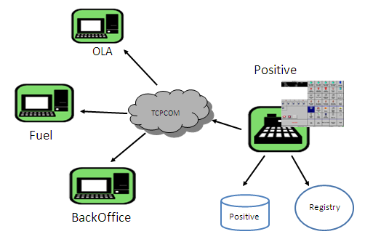

- BackOffice (BOS) - central point of the whole system. All sales information is maintained on the Pos as 'raw material' until it is transferred to the Back Office and is processed there for further control and reporting.
Use SP Data Flow.docx to learn more about POS and BOS relationships
- OLA – Online Authorization – Retalix protocol to links.
Responsibilities:
  - Give information about credit cards, other payment facilities and magnetic cards.
  - Authorize, Bill, and Report of currency transactions.
Find more detail in: OLA presentation.ppt
There is simulator of OLA: Simlink. For more detail: SimLinkSrv Users' Guide.doc
- Fuel – Fuel system.
- Positive database – The database of the positive. This database includes all the information about the employee, items, payment, access etc.
For more detail of the DB: StorePoint International DataBase Schemes.pdf
- Registry – The registry of positive include all the configuration of the system and found under HKEY_LOCAL_MACHINE\SOFTWARE\Positive\POSITIVE32
To have description about each registry key you can use the SetupBuilder.exe application.
For more detail of the registry: SetupBuilderGuide.docx.
You can also edit the most common keys be the Pos32Config.exe application. See more detail in Pos32Config.doc

Peripherals
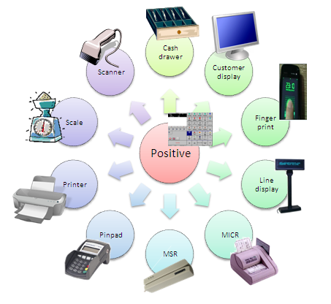

OPOS and fiscal

- OPOS - OLE (Object Linking and Embedding) for Retail POS - provides a consistent interface to POS peripherals for use by application creators.

POS Architectural Overview

Component view
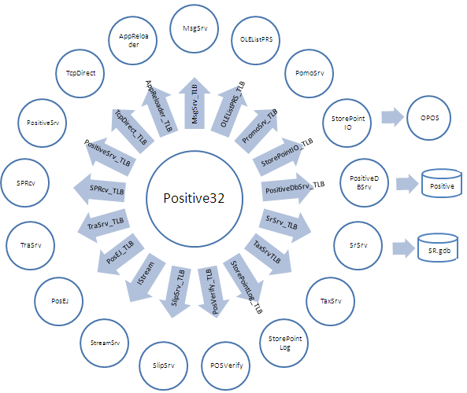

To know how to connect to the components see: HOWTO Connect to ComObject.docx

- Positive32.exe
Type: COM component. It is implemented in Delphi.
Responsibility: The component is in charge of the entire GUI and the first functionality of every event.
Dependencies: PositiveSrv.dll, PositiveDBSrv.dll, PromoSrv.dll, TraSrv.dll, StorePointIO.exe, SlipSrv.dll, SPRcv.exe, MsgSrv.exe, StorePointLog.dll, POSVerify.exe, OLEListPRS.dll, Stdvcl40.dll, Midas.dll, PosEJ.dll, Tutil32.dll, 3dabm7u.ocx, Delivery.dll, MaintSrv.dll, TcpComCln.exe.
Details: Positive32.docx

- PositiveSrv.dll
Type: COM component. It is implemented in Delphi.
Responsibility: The component realizes most of the functionality in the POS.
Dependencies: PositiveDBSrv.dll, TraSrv.dll, SlipSrv.dll, StorePointLog.dll, StorePointIO.exe, TcpComCln.exe, TaxSrv.dll, SlipSrv.dll, OLEListPRS.dll.
Details: PositiveSRV.docx
Interface: PositiveSrv_TLB.

- PositiveDBSrv.dll
Type: COM component. It is implemented in Delphi.
Responsibility: Data object layer (Each table in the DB connects to different unit in PositiveDBSrv).
Dependencies: StorePointLog.dll, MSXML2.dll.
Details: When POS starts in SrvLink.Create calls the function TDataAccess.ConnectDataBase that creates the entire Interface to the Database.
Interface: PositiveDBSrv_TLB.

- PromoSrv.dll
Type: COM component. It is implemented in Delphi.
Responsibility: Contain the connection to local promotion (call to PositiveDBSrv that connect to the DB) or to remote promotion (like LPE).
Dependencies: PositiveSrv.dll, StorePointLog.dll.
Details: Writes in the registry under HKEY_LOCAL_MACHINE\SOFTWARE\Positive\POSITIVE32\Promotions\UseBucketSystem:
0 – one-to-many – local promotions that come from Item table in Class field.
1- many –to-many – local promotion that come from ItemClassLines table and connect several itemId to the same class.
2- LPE – remote engine. See more detail in: Store Point LPE Integration.docx

3- Next Promo – remote engine from StoreLineIL
Interface: PromoSrv_TLB.

- TraSrv.dll
Type: COM component. It is implemented in Delphi.
Responsibility: Get trs file and write it to Tra file.
Dependencies: OLEListPRS.dll, StorePointLog.dll, PositiveDBSrv.dll.
Details: TraSrv.docx
Interface: TraSrv_TLB.

- StorePointIO.exe
Type: COM component. It is implemented in Delphi.
Responsibility: Peripherals link to OPOS.
Dependencies: OPOS (cash changer, printer, scanner, Micr, Line display, cash drawer, MSR, Scale, fiscal printer), MaintSrv.dll, POSEJ.dll, StorePointLog.dll.
Details: When POS starts in SrvLink.Create calls the function IOConnect that create IOSystemLink that create StorePointIO.
Interface: StorePointIO_TLB.

- SlipSrv.dll
Type: COM component. It is implemented in Delphi.
Responsibility: Receipt formatting.
Dependencies: MSXML2.dll.
Details: The main function GetSlipString gets the transaction and makes the receipt according to the setup in the registry under HKEY_LOCAL_MACHINE\SOFTWARE\Positive\POSITIVE32\SlipData

To learn how to configured the receipt see HOWTO Config a receipt.docx
Interface: SlipSrv_TLB.

- SPRcv.exe
Type: COM component. It is implemented in Delphi.
Responsibility: Retrieves data from BOS.
Dependencies: ParamSrv.dll, StorePointMSMQ.dll, StorePointLog.dll, TcpComCln.exe.
Interface: SPRcv_TLB.

- MsgSrv.exe
Type: COM component. It is implemented in Delphi.
Responsibility: Status messages. User interface controller.
Dependencies: StorePointLog.dll, StorePointIO.exe, MaintSrv.dll, 3dabm7u.ocx.
Interface: MsgSrv_TLB.

- StorePointLog.dll
Type: COM component. It is implemented in Delphi.
Responsibility: Charge to write log.
Details: We put this component in C:\WINDOWS\system32 so every component could be found her in the Delphi source (this need to be the only place that this component exists).
StorePointLog.docx – Not created yet !!!
Interface: use external function.

- POSVerify.exe
Type: COM component. It is implemented in Delphi.
Responsibility: Database integrity check.
Dependencies: StorePointLog.dll, TcpComCln.exe.
Details: Call in every start of the POS in SrvLink.Create if it configured in the registry under HKEY_LOCAL_MACHINE\SOFTWARE\Positive\POSITIVE32\DATA\ VerifyData.
Interface: PosVerift_TLB.

- OLEListPRS.dll
Type: COM component. It is implemented in Delphi.

Responsibility: Build X/Z reports to POS.

Details: When Make X/Z report the POS call TraSrv that use this dll. The OLEListPRS go over the tra file, check the department that exist and count each one of them separately.
The code don't exist.
Interface: OLEListPRS_TLB.

- PosEJ.dll
Type: COM component. It is implemented in Delphi.
Responsibility: Write the electronic journal of the POS.
Dependencies: StorePointLog.dll.
Details: EJ.docx
Interface: POSEJ_TLB.

- SRSrv.exe
Type: COM component. It is implemented in Delphi.
Responsibility: Save and Recall - Charge to save and recall transaction to/from the Database for transaction that not been finalized and transmitted to the BOS.
Dependencies: StorePointLog.dll.
Details: The transaction insert to the SR database in 2 ways:
- After Save event and release in Recall event.
- Fuel transaction that save on POS to move to fuel or start in fuel and move to POS.
Interface: SrSrv_TLB.

- TaxSrv.exe
Type: COM component. It is implemented in Delphi.
Responsibility: In country with more than 8 tax (Today: Indian and Canada) have TaxSrv component that calculate the tax.
Details: TaxSrv.docx.
Interface: TaxSrv_TLB.

- TcpDirect.dll
Type: COM component. It is implemented in Delphi.
Responsibility: Display the action in the POS to 3-Party so they can know what happen in the POS.
Details: For each action that happen in the POS the TCPDirect get message and the 3-Party application (such as camera system) can use this message to make something in her application.
Interface: TcpDirect_TLB.

- StreamSrv.dll
Type: COM component. It is implemented in Delphi.
Responsibility: Charge to the stream in the transaction, which include all the transaction information.
Interface: IStream.

- AppReloader.exe
Type: COM component. It is implemented in Delphi.
Responsibility: Start the POS.
Details: Call in Positive32, when need to restart automatically the POS.
The SrvLink run the AppReloader and kill the POS and then the AppReloader start the POS again.
Interface: AppReloader_TLB.

Stand alone tools
- TraEdit4.exe
Type: COM component. It is implemented in Delphi.
Responsibility: Viewer to the tra file.
Details: TraEdit4.docx.
Interface: TraEdit4_TLB.

- PdxScript.exe
Type: COM component. It is implemented in Delphi.
Responsibility: create PDX file from DB.
Details: HOWTO create new field in DB.docx.
Interface: None.

- VP.exe
Type: COM component. It is implemented in Delphi.
Responsibility: Virtual POS – get Self service transaction from fuel and write it to the tra.
Details; The VP doesn't include DB and only get buffer/xml from the PumpSrv and know how to translate the data to tra file.
Interface: VP_TLB.

- CustomerDisplay.exe
Type: COM component. It is implemented in Delphi.
Responsibility: Screen that connects to the Pos and displays all the details of the transaction for the customer.
Dependencies: SlipSrv, Flash.ocx.
Interface: CustomerDisplay.docx.

Main flow

Sale Transaction

- Start transaction could be for several transaction types: Sale, OTH, Waste, Refund, Void, NoSale, OpenBank, CloseBank, Float, Drop, PayIn, PayOut, TenderExchange, PostVoid, TerminalLock, TerminalUnLock, MoneyOrder, Shipment, Repay, ShiftLoan, ShiftDrop, LoyaltyBalanceInquiry, Deposit, LoanRepay, and Suspend.
- Add item could be for several item types: regular item, modifier item. Fuel item, SVS item, carwash item, Eservices item.
- Add payment could be for several payment types: cash, credit, hand credit, Check, Charge, coupon.

See more detail in POS\ Basic flow of Sale transaction.docx

Start transaction

End transaction

See more flow in POS\Events.docx
HOWTO create a new event.docx

External Components and Interfaces
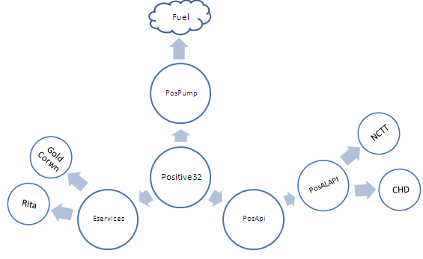

- PosPump.exe
Type: COM component. It is implemented in VB.
Responsibility: Pump Controller on the left hand side of the main screen can control the fuel.
Details: Fuel component.
See more functionality in Forecourt Data Flow.ppt

- POSAPI.exe
Type: COM component. It is implemented in Delphi.
Responsibility: Make a layer between the Positive32 to the PosILAPI.
Details: POSAPI.docx.
Interface: PositiveAPI_TLB.

- PosILAPI.exe
Type: COM component. It is implemented in Delphi.
Responsibility: Connect to 3-party application.
Details: POSAPI.docx.
The connection to the 3-party is by TCP/IP.
Interface: PosILAPI_TLB.

- EServices.exe
Type: COM component. It is implemented in Delphi.
Responsibility: Application that connect to 3-party.
Details: EServices.docx.
The connection to the 3-party is by TCP/IP.
Interface: Eservices_TLB.

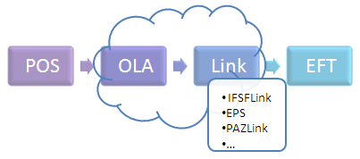
- OLASrv2.exe – Connect to different links that finally connect to the EFT.
- EFT - Electronic funds transfer - Is the electronic exchange, transfer of money from one account to another, either within a single financial institution or across multiple institutions, through computer-based systems.
- IFSFLink – Retalix component that convert the buffer from OLA to xml in IFSF protocol.
- EPS - Electronic Payment Services - Is simple use of ATM card or credit card with ATM function, no application of service is required.
The EPS could connect also to Pinpad instead of the POS and then connect to the EFT.
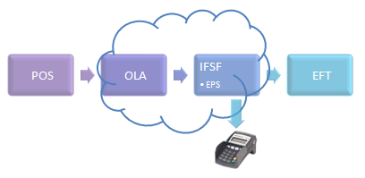

Interfaces

- IFSF - International Forecourt Standards Forum - designs standards for connecting devices on a service station forecourt, such as dispensers, Tank Level Gauges, Price Signs, Car Washes and Outdoor Payment Terminals. In recent years additional standards have been added for Electronic Funds Transfer.

3-Party
- Stdvcl40.dll
Responsibility: Use to ActiveX.
Details: Outsource component.

- Midas.dll
Responsibility: Necessary to work with ClientDataSet.
Details: Outsource component.

- Tutil32.dll
Responsibility: Necessary to work with POSVerify.
Details: Outsource component.

- 3dabm7u.ocx
Responsibility: Charge to the base button of the POS GUI.
Details: Outsource component.

Repository

Database
The database alias of the POS calls POSITIVE that is paradox.
POS only reads from the database that is written by BOS.


PositiveDBSrv include Dataset for each table.
See more detail in HOWTO create new field in DB.docx

The database alias for the SrSrv calls SR that is interbase.
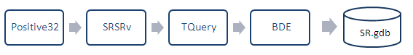

Tra file
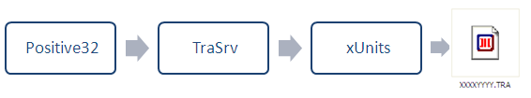
TraSrv.dll charges to write Tra file so the BOS can read it and make report according to this data.
POS terminals create their own individual TRA file(s) within each POS Batch. During the POS Batch multiple transactions are added to the TRA File.
To view the tra file you can use the traEdit4 application.

See more detail in POS\TraSrv.docx
To be able to view the tra file need to use the TraEdit4 application. See more detail in TraEdit4.docx
In case the tra was corrupt for some reason there is way to fix it in

HOWTO Handle bad TRA files.doc
If need to add new record to the tra file use can use the HOWTO create a new record in tra.docx
Some customer work with MSMQ to copy the Tra file from the Pos to the BOS.
MSMQ, Microsoft Message Queuing, is a messaging protocol that allows applications running on separate servers/processes to communicate in a failsafe manner.
In that way the POS sure that the tra file will be move to the BOS and the POS can do another thing.

Trs file

Open transactions (transactions that are still in progress) will be held as TRS files until finished.
The TRS file includes all the records the transaction has.

Registry
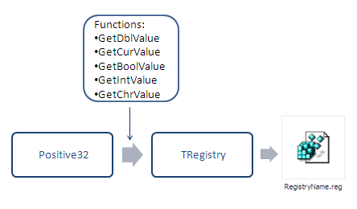
Registry key read/write in several components.
To read registry key use the functions: GetDblValue/ GetCurValue/ GetBoolValue/ GetIntValue/ GetStrValue according to the type you want to read.
To write registry key use the function SetBoolValue/ SetIntValue/ SetStrValue/ SetDblValue.
Add the TNK way

Ini file

Ini file read/write in PositiveSrv.
The ini file use to have backup to the registry in case of crush or other reason.
In the ini file Pos save the transaction number (for any type), shiftId, and the position that tra stop to write (TRA_GSerNum, TRA_SerNum), operator id and other thing that important to the sequence of the POS.

